Task 14 : EC2 and Amazon EBS

1. Amazon EBS vs Amazon S3 Comparison
Feature | Amazon EBS | Amazon S3
Data Type | Block Storage | Object Storage
Access Method | Attached directly to an EC2 instance as a disk | Accessed using AWS APIs, SDKs, or HTTP/HTTPS
Primary Use Case | Operating systems, databases, applications, and boot volumes | Images, videos, backups, documents, and static website files
Scalability | Can increase volume size, but attached to one EC2 instance at a time (except Multi-Attach for supported volumes) | Virtually unlimited storage capacity and automatic scaling
Performance | Low latency and high IOPS | Optimized for durability and large-scale object storage
Real-World Example | Flipkart: Stores database and application files for order processing | Zomato: Stores restaurant images, menu photos, and customer uploads

2. Launch EC2 and Attach 2 GB EBS
• Launch Free Tier Amazon Linux EC2.
• Create a 2 GB EBS volume in same AZ.
• Attach it to the instance as /dev/xvdf.
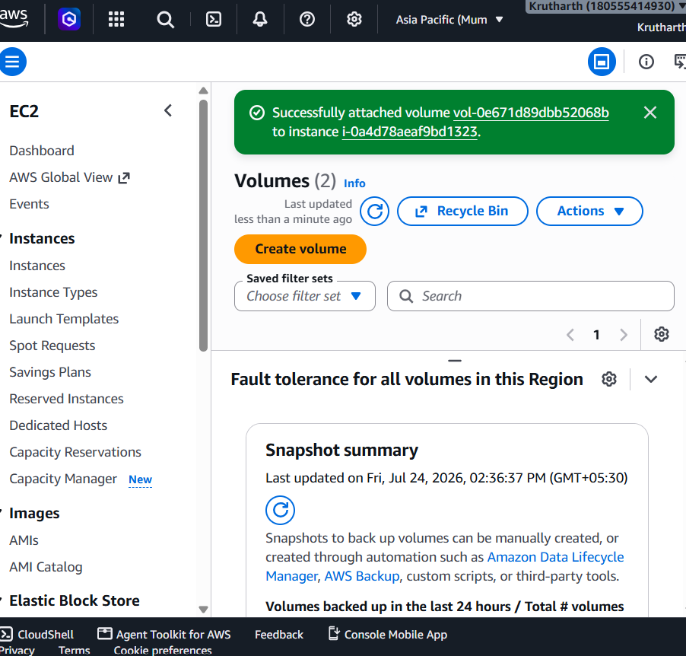

3. Format and Mount
lsblk
sudo mkfs -t ext4 /dev/xvdf
sudo mkdir -p /mnt/mydata
sudo mount /dev/xvdf /mnt/mydata
df -h
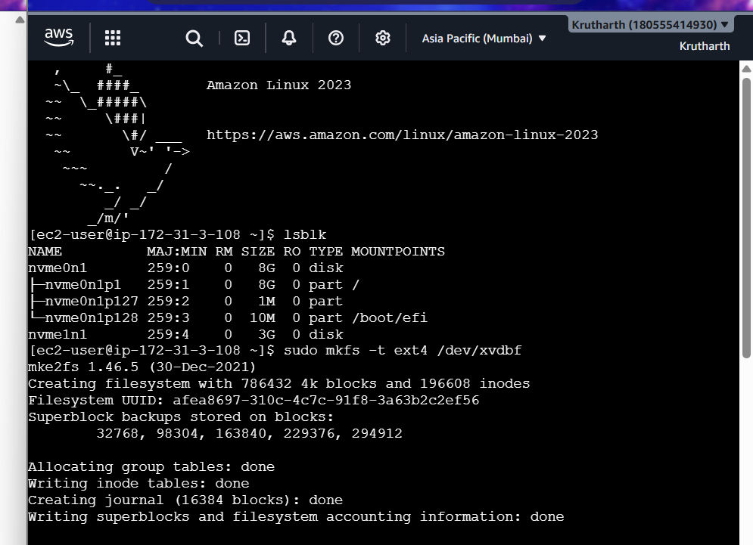
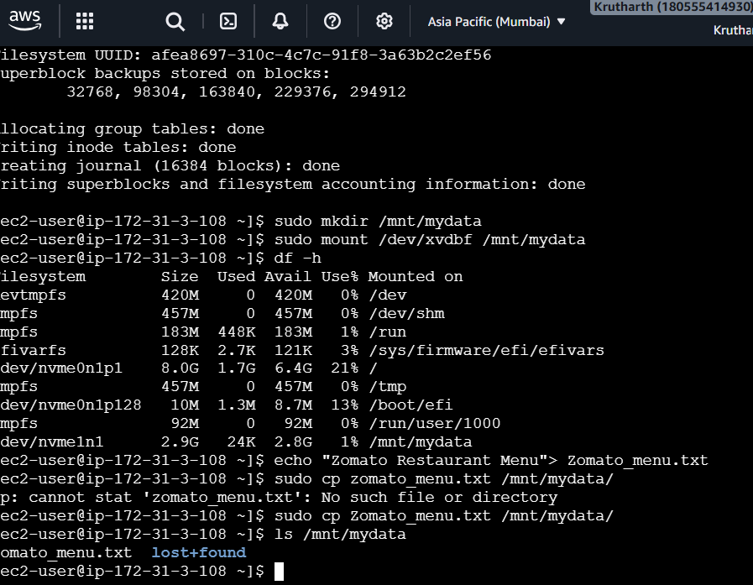

4. Create and Copy File
echo "Zomato Menu Items" > zomato_menu.txt
sudo cp zomato_menu.txt /mnt/mydata/
ls /mnt/mydata
cat /mnt/mydata/zomato_menu.txt
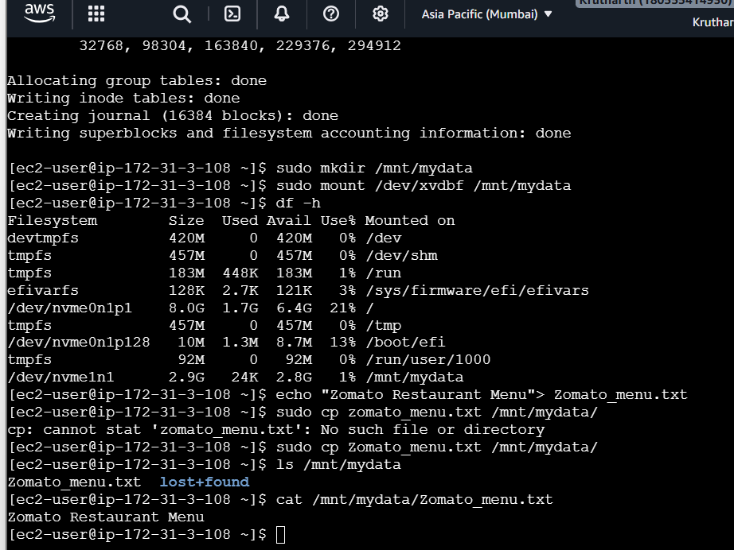

5. Detach and Reattach
Detach the volume from the AWS Console, reattach it to the same or another EC2 instance, mount it again, and verify the file still exists.
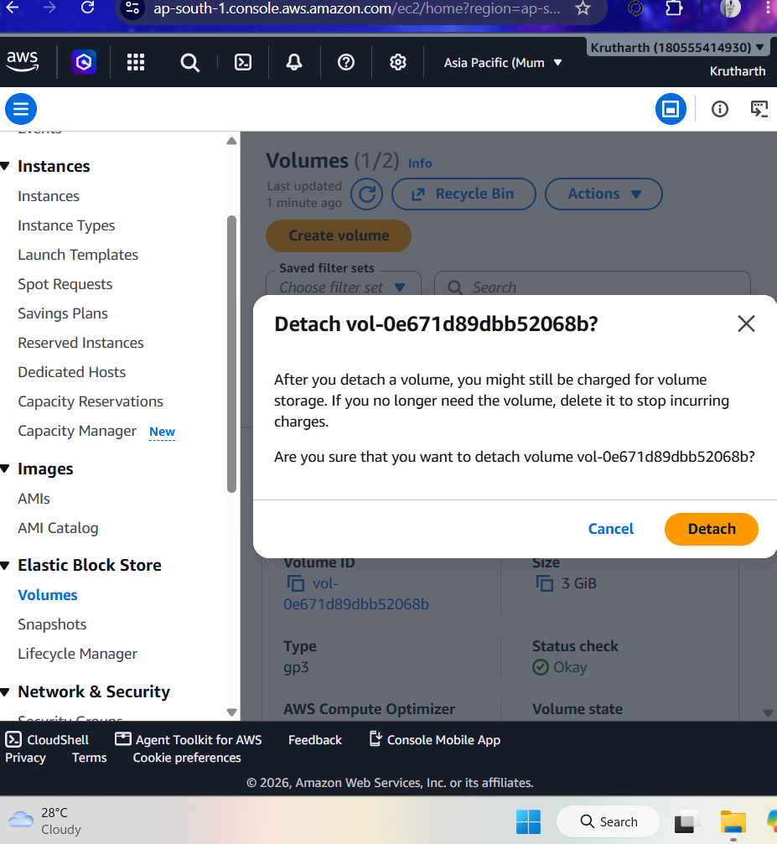
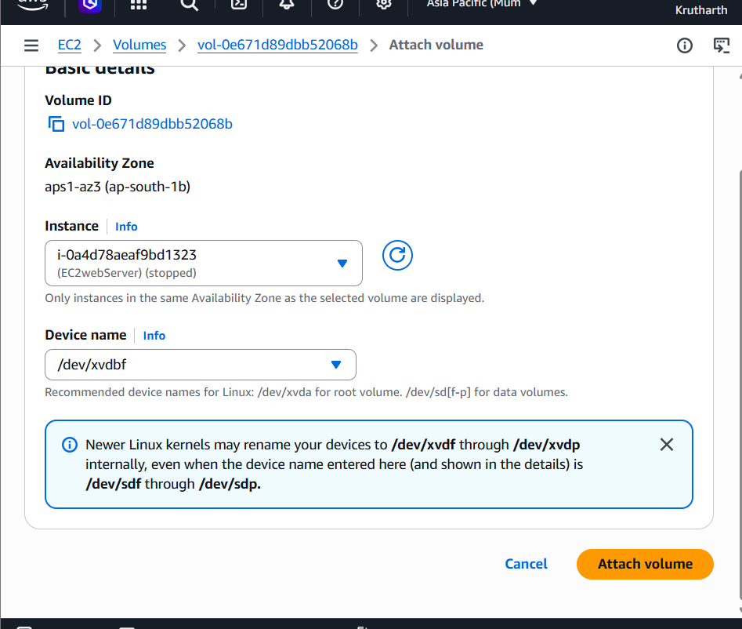
The data remains because Amazon EBS is persistent block storage independent of the EC2 instance. This is useful for applications like Flipkart or Myntra because order and application data survive instance replacement or failure.

